creche child enrolment form
Childs Full Name: |  |  | Date of Birth: |  |  | Age:
Child 2: |  |  | Date of Birth: |  |  | Age:
Child 3: |  |  | Date of Birth: |  |  | Age:
Child 4: |  |  | Date of Birth: |  |  | Age:
ADMIN USE ONLY:
Birth Certificate Attached for each child (required before creche sessions are booked) □ YES □ NO
ALLERGIES/ILLNESSES
Does your child/ren suffer from any medical or physical condition that crèche staff need to be aware of? □ YES □ NO
For example: special dietary requirements, allergies, anaphylaxis (EpiPen must be brought to creche sessions), medical conditions, epilepsy, asthma

If yes, please provide details of condition and any medications taken:
Care plan attached: □ YES □ NO

parent/guardian information – primary PARENT
Parent Full Name:
Mobile: |  |  | Email:
Address:

parent/guardian information – secondary PARENT
Parent Full Name:
Mobile: |  |  | Email:
Address:
Preferred contact for Oasis Creche correspondence: □ Primary Parent □ Secondary Parent

EMERGENCY CONTACT

OTHER THAN PARENT OR GUARDIAN
Full Name: |  |  | Mobile:
Address:
Relationship to child:

agreement to enrolment terms

□ I accept that I must stay on the premises while my child is in crèche care, and I understand that I am responsible for my child whilst I attend the activity/course within the facility. If I do leave sign and crèche staff are unable to reach me, I’m aware the police will be called.
□ I understand and accept that it is my responsibly to respond immediately to my child in crèche care when requested by the centre staff.
□ I consent to medical treatment being obtained for my child in case of an emergency.
□ I have attached my child’s Birth Certificate
□ I have provided an up-to-date Medical Care plan (if necessary)
□ I agree to the crèche Usage and Polies outlined in this document.

Parent Name: __________________________________ Signature: __________________________ Date: __ / __ / ___
ADMIN USE ONLY – STAFF NAME:
Birth Certificate Sighted by:  _______________________________ |  | Scanned by:  _______________________________ |  |  | Entered into Envibe by:  _______________________________

Important Oasis Crèche policies
These policies are formed in conjunction with the Department of Communities to meet the requirements of unlicensed crèche center’s.

AGREEMENT TO CRECHE POLICIES
- BOOKINGS: Can be made via the Goldfields Oasis website. Online sales will end 3 hours prior to the start of each care session. Booking must be made under the child/ren that will be attending crèche.
- CANCELLATIONS: Cancellations are essential and are required to be made via phone (9021 0900) or email (oca@ckb.wa.gov.au). Cancellations by phone can only be made during crèche opening hours. All cancellations must be made 24hrs prior to your booking in order to reschedule your session with no extra charge. Cancellations made outside of these time frames will not be rescheduled free of charge unless a medical certificate can be supplied.
- LATE COLLECTION FEE: I am aware $6.00 is payable per 5 minute intervals late (per child). Care sessions will be refused if a late collection fee remains outstanding at the time of arrival to your next scheduled booking. A refund will not apply. Options to pay on the day will be available.
- It is important to include all locations you will be during your visit, this helps if a staff member needs to retrieve you at any stage.
- You must remain on the premises whilst your child attends crèche
- I am aware my care session starts from the time my booking was pre-scheduled and not from the time I arrive to crèche.
- The person dropping of the child must be the one to collect them unless an Authorization for Collection Form has been completed.
- I am aware that crèche is closed on all Public Holidays
- I have read and agree to the Creche Behavior and Aggressive Behavior Policies (attached to parent handbook)
- LABEL ALL ITEMS: Please ensure all bags, food and drinks are labelled, this helps us to ensure the best care for your child. ANY UNLABELED FOOD OR DRINKS WILL NOT BE GIVEN OUT.
ADMINISTRATION OF MEDICATIONS
- I have read and fully understand the medication requirements in the Oasis Creche Parent Handbook
- Creche staff are not authorized to administer medication of any sort. This includes sunscreen and nappy cream. If a child needs medication, crèche staff will advise parent, and they must respond immediately.
- If my child requires an action plan for a medical condition or allergy, I will provide a copy to the Oasis Creche in case of emergencies.
- If my child/rens medical details change in any way I will advise crèche staff
PHOTOGRAPHY/VIDEOGRAPHY CONSENT
- I agree to give consent for the staff at the Goldfields Oasis Creche to take photos or video of my child/ren. I understand the photos or videos may be used for any Goldfields Oasis promotional material (optional)
- I do not give consent for photography or videography
Parent Full Name:
Signature: |  | Date: | __ / __ / ___
Creche Staff Name: |  | Sign:

How to Book Creche Online
- Open Goldfields Oasis website – www.goldfieldsoasis.com.au Or Goldfields Oasis App
- Select “Log In” – top right corner
- Log In to your account or create a new account (you will get a confirmation email sent to your inbox)
- In the top right corner click on your name eg. JOHN SMITH
- Click ”My Account” then “Select User” and choose which child you wish to book in
  - Note: If you are booking multiple children in for the same time slot – please book under your own name and state your children’s full name and age in the notes. This is ONLY for multiple bookings.
- Once you have switched users, select “Home” from the left side corner.
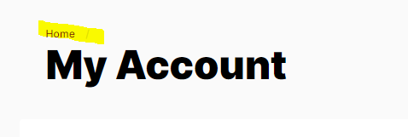
- Select the Bookings tile
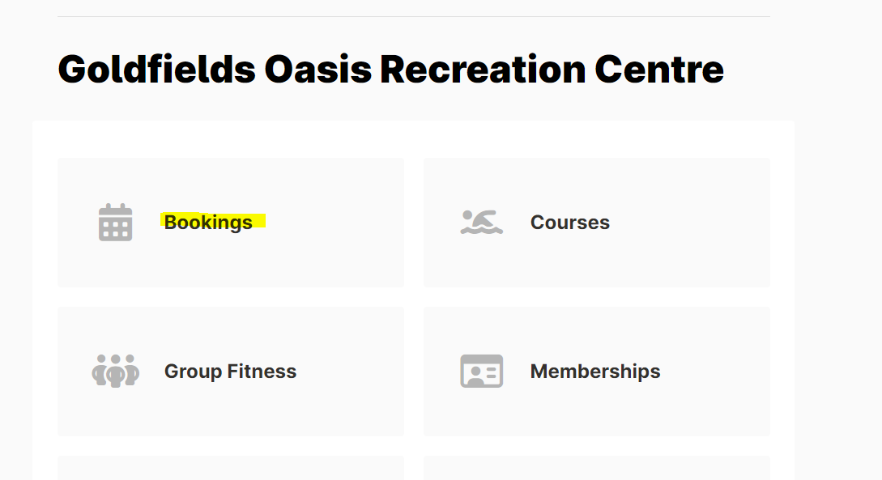
- Number of spaces remains at 1 (for 1 child) and Estimated group size remains at 0.
- Select your desired date, then click the desired start time and end time. Then select Continue.
Please note for start and end times after 11:45am please select the “PM” tab.
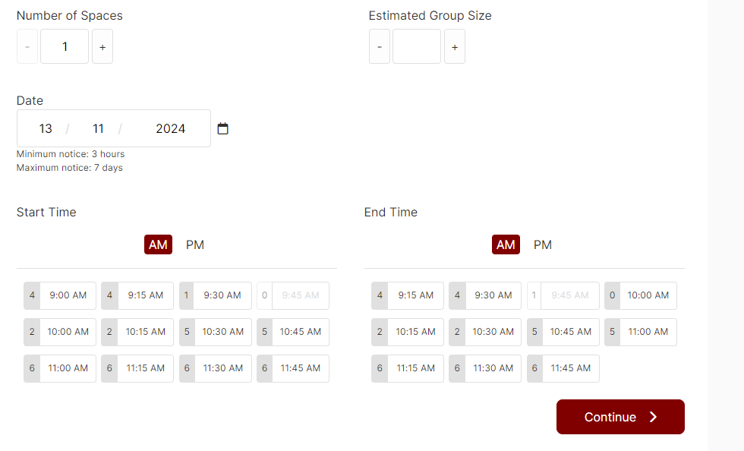

- If you are booking in for multiple children, please write their names and ages in the Notes section.
- If you would like to make more bookings for the same child click “Book More” button and repeat process.
- Once you have completed your desired bookings select “Add to Cart” and follow prompts to complete payment.

